HONG KONG INSTITUTE OF VOCATIONAL EDUCATION
Laboratory 4b: Inheritance

TASK:

1. You are given the following classes:

class Worker:
__number_of_workers = 0
def __init__(self, name):
self.__name = name
Worker.__number_of_workers += 1
def set_salary(self, salary):
self.__salary = salary
def get_salary(self):
return self.__salary
def get_name(self):
return self.__name
@staticmethod
def get_number_of_workers():
return Worker.__number_of_workers

class FTWorker(Worker):
def __init__(self, name, monthly_income):
super().__init__(name)
self.set_monthly_income(monthly_income)

def set_monthly_income(self, monthly_income):
self.__monthly_income = monthly_income
super().set_salary(monthly_income)

class PTWorker(Worker):
pass

class CommissionWorker(PTWorker):
def __init__(self, name, commission, quantity):
super().__init__(name)
self.__commission = commission
self.__quantity = quantity
super().set_salary(self.__commission * self.__quantity)

def set_commission(self, commission):
self.__commission = commission
super().set_salary(self.__commission * self.__quantity)

def set_quantity(self, quantity):
self.__quantity = quantity
super().set_salary(self.__commission * self.__quantity)

class HourlyWorker(PTWorker):
def __init__(self, name, wage, hours):
super().__init__(name)
self.__wage = wage
self.__hours = hours
super().set_salary(self.__wage * self.__hours)

def set_wage(self, wage):
self.__wage = wage
super().set_salary(self.__wage * self.__hours)

def set_hours(self, hours):
self.__hours = hours
super().set_salary(self.__wage * self.__hours)

The following template is given for you to write your client program:

if __name__=="__main__":
list_worker = list()
list_worker.append(FTWorker("Kelvin", 15000))
list_worker.append(CommissionWorker("Mary", 1200, 10))
list_worker.append(HourlyWorker("Peter", 80, 160))
# a. Print total number of workers

# b. Print original salary

# c. Set new values to instance variables

# d. Print updated salary

To produce the output below:
There are 3 workers in total
Original salary:
Kelvin earned $15000
Mary earned $12000
Peter earned $12800
Updated salary:
Kelvin earned $18000
Mary earned $13500
Peter earned $16200

- Write code to print the total number of workers
- Write code to print the original salary. You have to use for loop to construct and print the output
- Write code to set Kelvin’s monthly income to 18000, Mary’s commission to 1500, Mary’s quantity to 9, Peter’s wage to 90, and Peter’s hours to 180
- Write code to print the updated salary after new values are set to instance variables. You have to use for loop to construct and print the output

Answers:

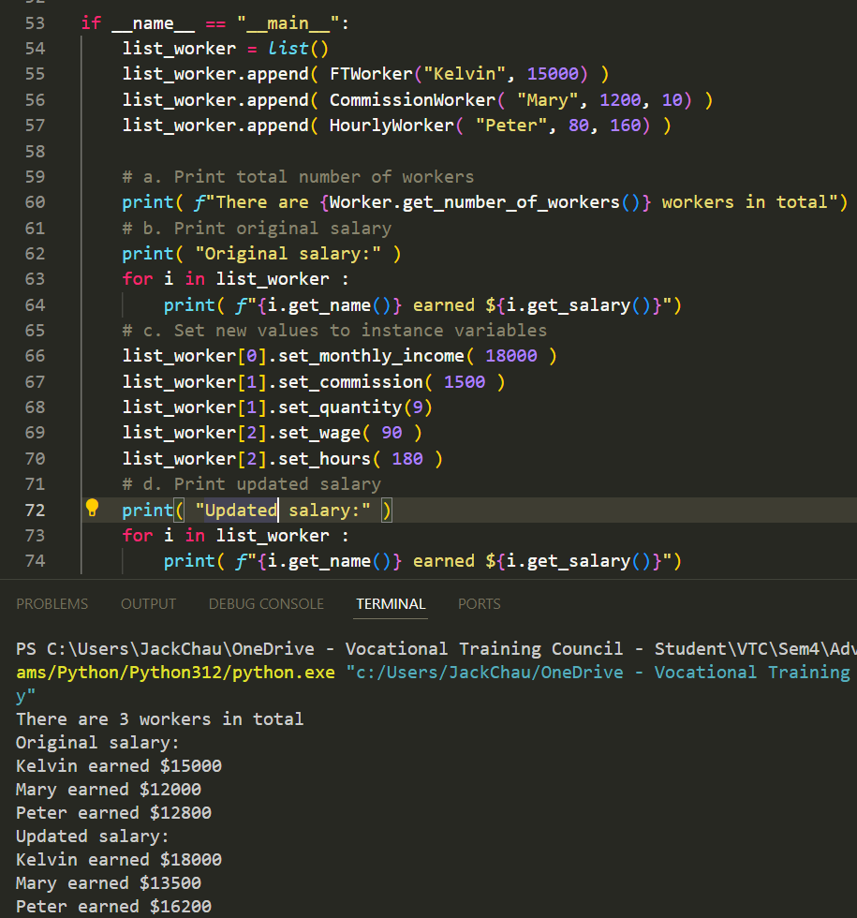

2. Write the supplier classes in the following parts below.
BankAcct

__id : str
__name : str
__balance : float

__init__ (self, id, name)
service_charge (self) : float
deposit (self, amount)
withdraw (self, amount)

SavingAcct

NO_OF_FREE_WITHDRAW = 2 : int
AMOUNT_OF_CHARGES = 20 : int
__no_of_withdraw : int

__init__ (self, name)
service_charge (self)
withdraw (self, amount)
CurrentAcct

NO_OF_CHARGED_CHEQUE = 2 : int
AMOUNT_OF_CHARGES = 10 : int
__no_of_cheque : int
__init__ (self, name)
service_charge (self)
withdraw (self, amount)
(a) Create a class BankAcct that has:
Attributes:
__id – to store the id of bank account
__name – to store the name of customer
__balance – to store the balance of this bank account
Methods:
__init__ – initialize the id and name attribute of bank account object. Initialize the balance attribute to 0 when a bank account object is created
service_charge – just return 0 for this method. Since calculation of service charges for different account type are different
deposit – to handle deposit of specified amount of money into bank account. If deposit amount is greater than 0, add the current amount into account balance and print the successful message. Else print the failed message.
withdraw – to handle withdraw of specified amount of money from bank account. If withdraw amount is greater than 0 and bank account has enough balance, deduct the current amount from account balance and print the successful message. Else print the failed message. Finally, check if the service charge is greater than 0 or not. Deduct service charge from balance and print the message if service charge is greater than 0

(b) Create a class SavingAcct inherit from class BankAcct that has:
Attributes:
NO_OF_FREE_WITHDRAW – a constant to store the number of free withdrawal without service charge. Assign it to 2 as specified by question.
AMOUNT_OF_CHARGES – a constant to store the amount of charges for every withdrawal afterwards. Assign it to 20 as specified by question.
__no_of_withdraw – an instance variable used to store the number of withdrawal of this account. Used for calculation of service charges.
Methods:
__init__ – initialize the name attribute of saving account object. Super method call is used to call parent class __init__ method to initialize the bank account id and name attribute. Bank account id is a combination of “S” character (means saving account) plus a random integer from 100000 to 999999. Initialize the no_of_withdraw attribute to 0.
service_charge – override the parent class service_charge method to check if current number of withdraw is greater than the number of free withdraw, return the service charge of saving account (i.e. $20) if it is the case. Else return 0.
withdraw – override the parent class withdraw method to count the number of withdrawal additionally. Add 1 to current number of withdraw. Super method call is used to call parent class withdraw method to handle withdrawal of specified amount.

(c) Create a class CurrentAcct inherit from class BankAcct that has:
Attributes:
NO_OF_CHARGED_CHEQUE – a constant to store the number of cheque (withdrawal) that would be charged. Assign it to 2 as specified by question.
AMOUNT_OF_CHARGES – a constant to store the amount of charges for every cheque (withdrawal). Assign it to 10 as specified by question.
__no_of_cheque – an instance variable used to store the number of cheque (withdrawal) of this account. Used for calculation of service charges.
Methods:
__init__ – initialize the name attribute of current account object. Super method call is used to call parent class __init__ method to initialize the bank account id and name attribute. Bank account id is a combination of “C” character (means current account) plus a random integer from 100000 to 999999. Initialize the no_of_cheque attribute to 0.
service_charge – override the parent class service_charge method to check if current number of cheque is smaller than or eques to the number of charged cheque, return the service charge of current account (i.e. $10) if it is the case. Else return 0.
withdraw – override the parent class withdraw method to count the number of withdrawal additionally. Add 1 to current number of cheque. Super method call is used to call parent class withdraw method to handle withdrawal of specified amount.

(d) Test the above classes with the client / driver program and sample output given below. You are NOT allowed to modify the client / driver program.

if __name__ == "__main__":
list_bankacct = list()
list_bankacct.append(SavingAcct("Kelvin"))
list_bankacct.append(CurrentAcct("Mary"))
list_bankacct[0].deposit(10000)
list_bankacct[1].deposit(8000)
list_bankacct[0].withdraw(12000)
list_bankacct[0].withdraw(7000)
list_bankacct[0].withdraw(3000)
list_bankacct[1].withdraw(1000)
list_bankacct[1].withdraw(2000)
list_bankacct[1].withdraw(3000)

Sample Output:
Customer Kelvin deposit 10000 into account S996801 successfully, account balance is 10000
Customer Mary deposit 8000 into account C526843 successfully, account balance is 8000
Customer Kelvin withdraw 12000 from account S996801 is not successful
Customer Kelvin withdraw 7000 from account S996801 successfully, account balance is 3000
Customer Kelvin withdraw 3000 from account S996801 is not successful
Service charge 20 is deducted from account S996801, account balance is 2980
Customer Mary withdraw 1000 from account C526843 successfully, account balance is 7000
Service charge 10 is deducted from account C526843, account balance is 6990
Customer Mary withdraw 2000 from account C526843 successfully, account balance is 4990
Service charge 10 is deducted from account C526843, account balance is 4980
Customer Mary withdraw 3000 from account C526843 successfully, account balance is 1980

Note:
- Account ID will be different for every program execution
- Unsuccessful withdrawal also counts for no. of withdraw when calculating service charges
- Withdrawal would be unsuccessful if balance is insufficient for the withdrawal amount together with service charges.
- Service charge will be charged even if the withdrawal is not success.

Answers:
